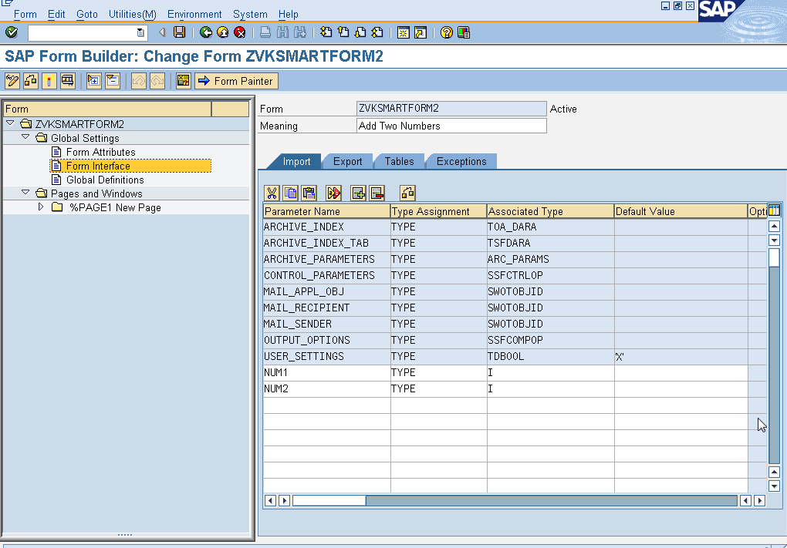

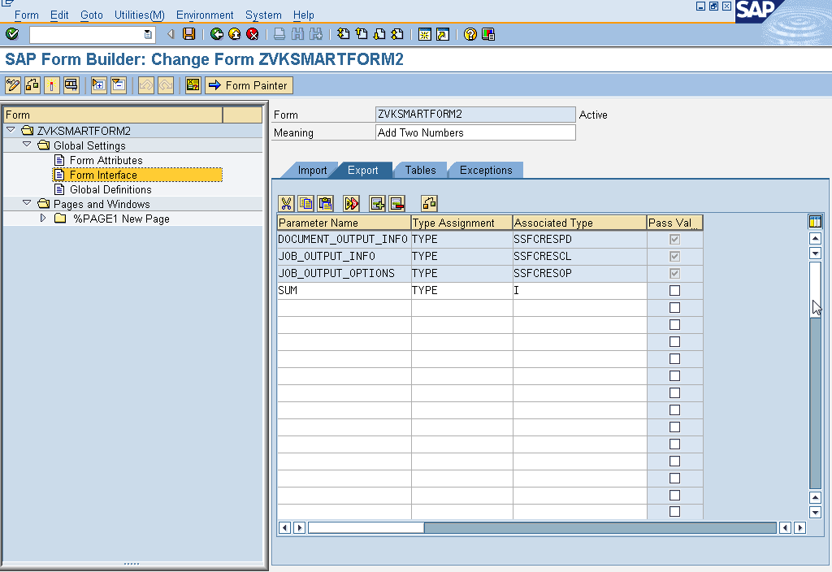

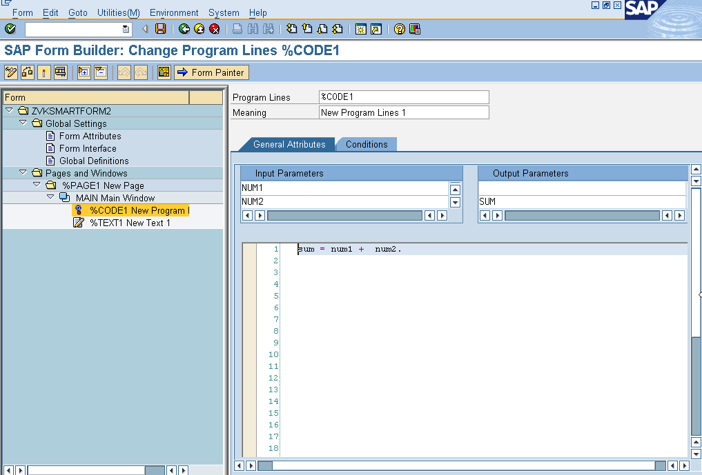

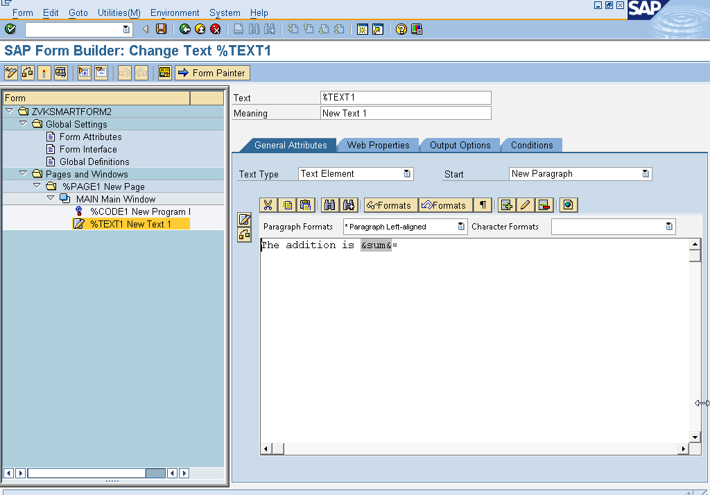

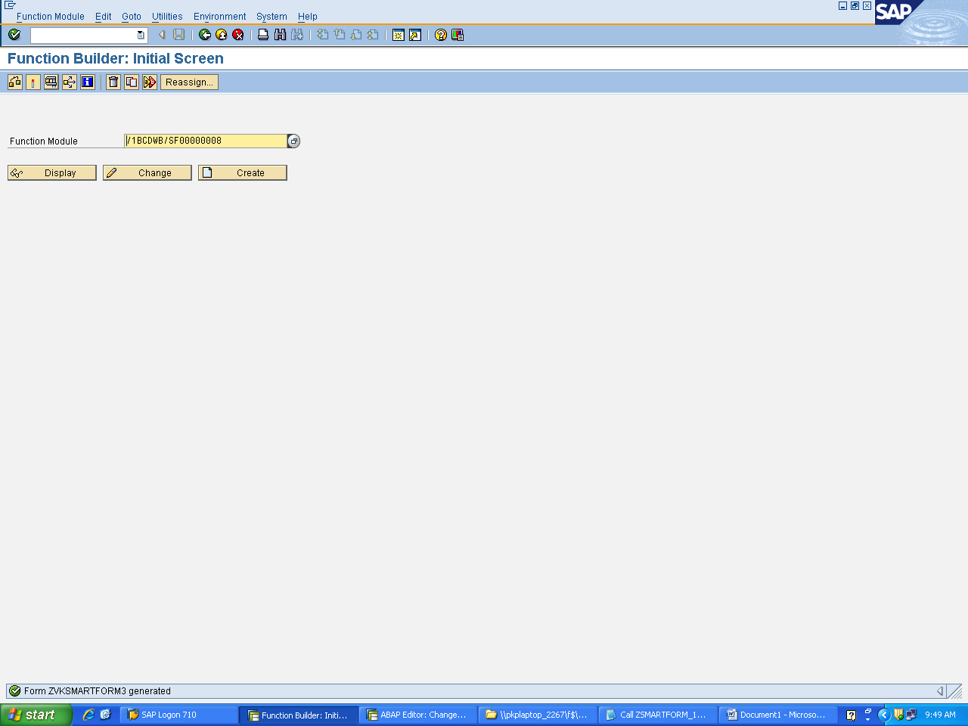

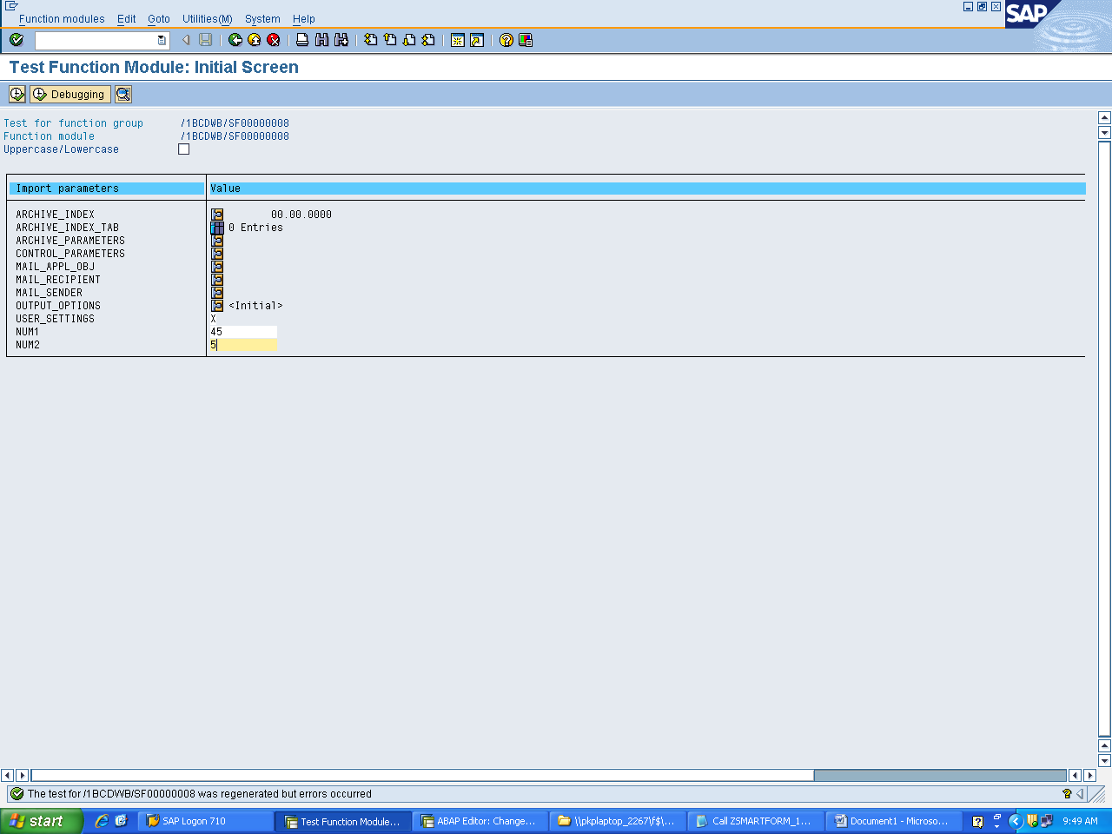

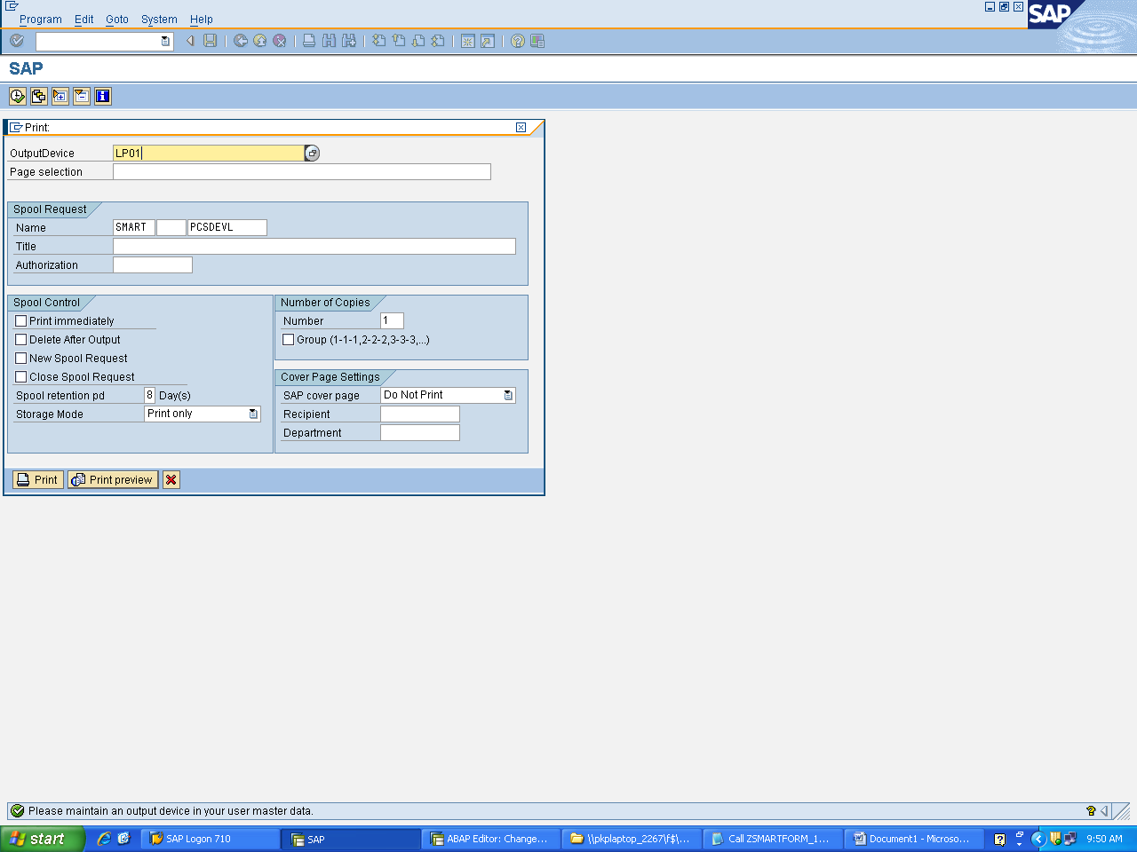

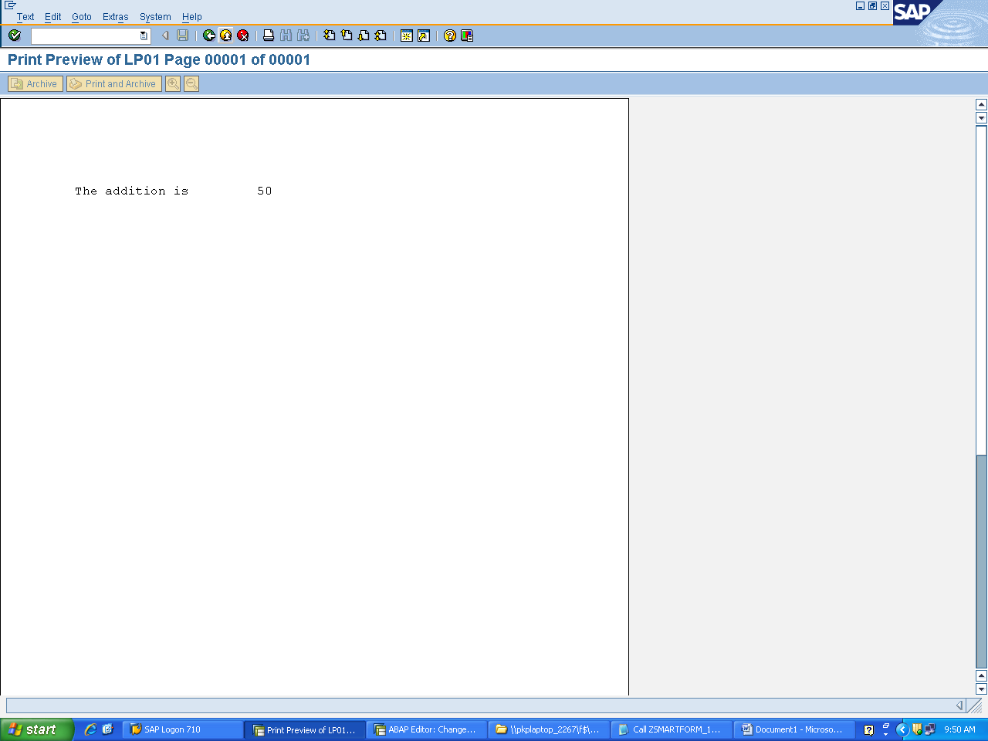

Calling the program from the editor

DATA : FM_FORM TYPE RS38L_FNAM.  
DATA: N1 TYPE I VALUE 10,  
      N2 TYPE I VALUE 11,  
      RES TYPE I VALUE 0.  
CALL FUNCTION 'SSF_FUNCTION_MODULE_NAME'  
    EXPORTING  
      formname                 = 'ZVKSMARTFORM2'   "formname  
   IMPORTING  
     FM_NAME                  = FM_FORM.  
  
  IF sy-subrc <> 0.  
* MESSAGE ID SY-MSGID TYPE SY-MSGTY NUMBER SY-MSGNO  
*         WITH SY-MSGV1 SY-MSGV2 SY-MSGV3 SY-MSGV4.  
  ENDIF.  
  
CALL FUNCTION FM_FORM  
    EXPORTING  
      NUM1 = N1  
      NUM2 = N2  
  IMPORTING  
      SUM = RES.  
WRITE: ' THE RESULT IS:' , RES.  
IF sy-subrc <> 0.  
 MESSAGE ID SY-MSGID TYPE SY-MSGTY NUMBER SY-MSGNO  
         WITH SY-MSGV1 SY-MSGV2 SY-MSGV3 SY-MSGV4.  
ENDIF.

IN THE ABOVE CASE SUM IS DECLARED AS AN EXPORTING PARAMETER.

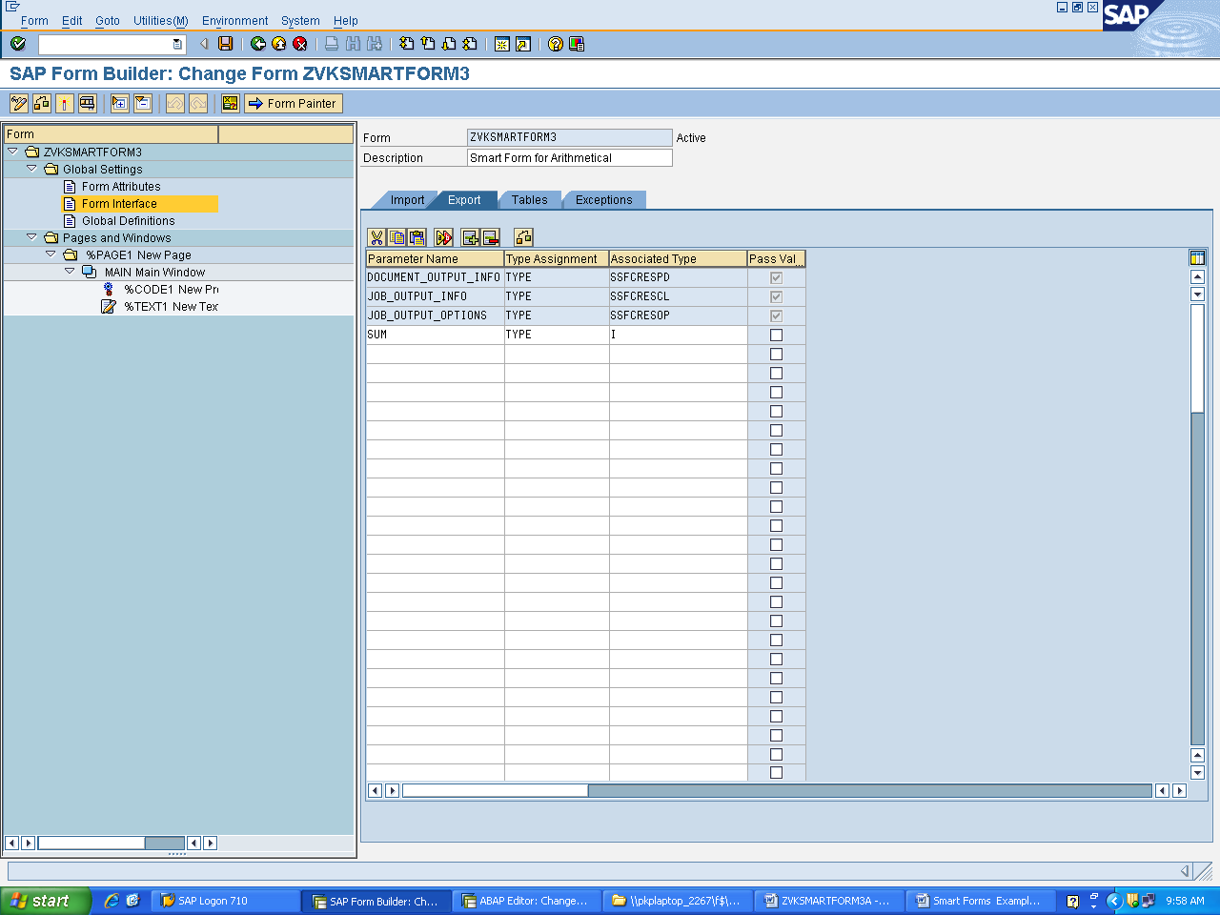

Variables which are declared in the form interface as import or export parameters need not have global definitions as they will be passed from the calling program written in editor.